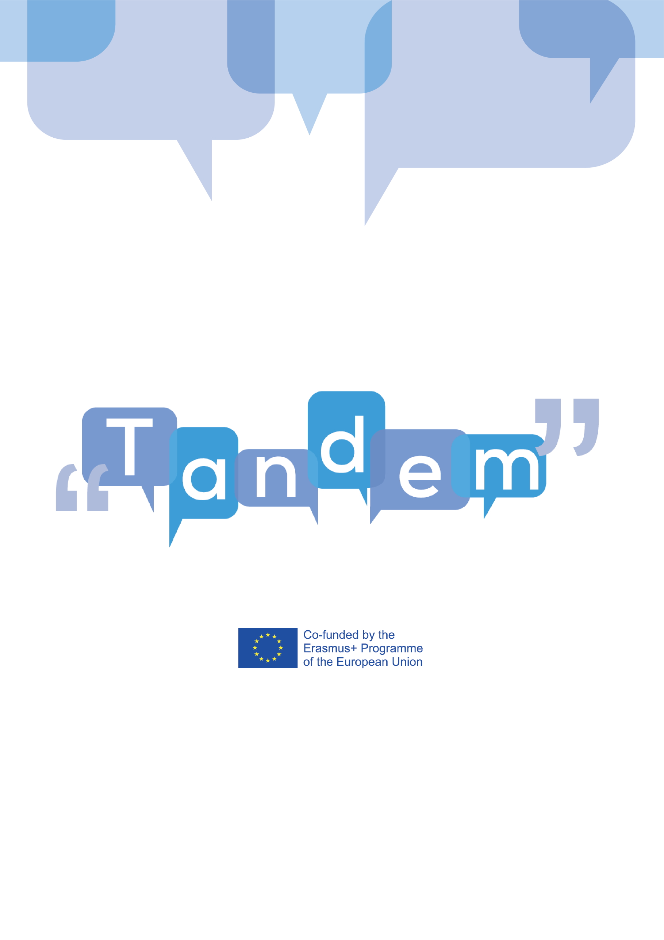

MODULE 3 - TOPIC 3.3.1: WHAT IS A TBLT CURRICULUM

In this video, you will learn what a language curriculum is, and you will be introduced to the two main approaches in designing language curricula. You will also examine more carefully the structure of a TBLT curriculum, which you can consider when you will design yours.
What does language curriculum mean? It is basically a document which provides information of what should be learnt in the language class, along with a rationale for how that content should be selected, ordered, taught, and assessed or evaluated.
There are 2 different approaches for constructing curriculum. One is based on choosing specific items to be learnt and is what we have all experienced at school. So, in this traditional approach, the curriculum is based on grammar and vocabulary structures (what should be learnt) and has learning objectives in terms of language. The second one determines how and for what purpose learners learn and then creates the content. A TBLT curriculum follows this second line.

Now, how do tasks connect to a TBLT curriculum? Well, this kind of curriculum is based on a series of tasks put together in a row (which is called task-sequence), under different topics and lessons. Through the tasks, the learners are put in situations where they create a real communicational outcome while language learning also happens.

Let’s examine a graph to see which the important elements in a TBTL curriculum are:
- As we can see in the graph, before the TBLT curriculum is designed, it is suggested that there is an evaluation of the learners’ needs, which will be the base to detect possible difficulties in learning and give guidelines for the tasks that should be done in the course.

- Some more important elements are:
- The scope and objective of your lessons (Which are the objectives of my lesson(s)? Which tasks are important for my class? Which are the target ones?)
- The sequence of the tasks (How can they be sequenced? Does one task relate to another? If yes, which task should come first, and which second?)
- The materials you will use (Which are the necessary ones so the learners can perform a task? Shall I ask them to bring something? Shall I bring a cookbook?)
- Other factors that are related to your teaching (i.e., How much time do I have? How will the students work? Individually, in pairs, in groups? At what point should learners practice each language skill?)

- After the curriculum is designed, the lesson can take place. The communicative outcome of the task will define whether the learners have reached the target, which is to perform the task and use the language to accomplish it.

- In TBLT, the evaluation process is a continuous process. In the traditional approach, the evaluation of the learners is based on the form, whether the learners have learnt the grammar. In contrast, in TBLT, the assessment is done evaluating the communicative outcome of the task, whether the learners can perform it. This is why language objectives that focus on form cannot be the main objectives of the TBLT curriculum.

A TBLT curriculum can be developed having in mind the different points of the scheme. However, the different parts have to be re-designed and re-evaluated through the course to further adapt them to learners’ needs; so it is not a linear, set procedure. In order to see how this information becomes a real lesson in practice, you can check both the TANDEM Open Textbook and module 4.

In the next videos, we will examine all the elements of a TBLT curriculum, starting from the learners’ needs. At the end of the module, we will come back to put it all together so you can reach to design a successful TBLT curriculum.

BIBLIOGRAPHY:
- Chamani. F. (2016). Task-based syllabus. Retrieved, March 10, 2021 from: https://www.slideshare.net/faribachamani2010/task-based-syllabus-60466332
- Ellis, R. (n.d.), The Methodology of Task-Based Teaching. Retrieved February 2, from: https://www.kansai-u.ac.jp/fl/publication/pdf_education/04/5rodellis.pdf?web=1&wdLOR=cAD6E994B-C658-4216-9CF0-C08F01DE6DF9
- Frost, R. (n.d.). A task-based approach. Retrieved March 9, 2021 from: http://www.teachingenglish.org.uk/think/articles/a-task-based-approach
- Hill, Y. & Tschudi, S. (2011). Exploring Task-Based Curriculum Development in a Blended-Learning Conversational Chinese Program. International Journal of Virtual and Personal Learning Environments, 2 (1), 19-36. Retrieved from: https://www.researchgate.net/publication/220066322_Exploring_Task-Based_Curriculum_Development_in_a_Blended-Learning_Conversational_Chinese_Program#pf5
- Kazeroni, A. (1995). Task-based language teaching. ASp [Online], 7-10. Retrieved March 9, 2021 from: http://journals.openedition.org/asp/3750.
- Rooney, K. (1998). Designing a Task-Based Syllabus and Materials for Tyndale Level 1. Retrieved February 20, 2021 from: https://www.collectionscanada.gc.ca/obj/s4/f2/dsk2/ftp01/MQ39036.pdf
- Willis, J. (2018). Task design: One topic, five levels, 15 task sequences (IATEFL Brighton). Retrieved February 19, 2021 from: http://www.willis-elt.co.uk/conference-presentations/

