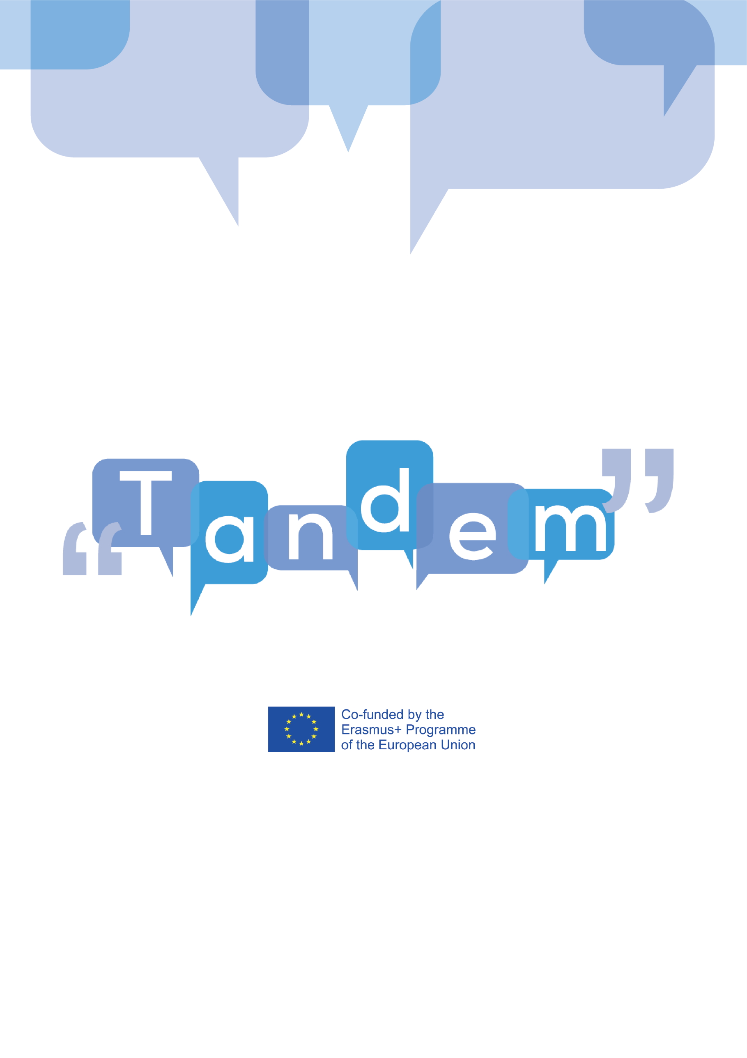

MODULE 3 - TOPIC 3.6.5: ADAPTING YOUR MATERIAL

(VIDEO TRANSCRIPT)

In this video, we will talk about how you can check if an activity is a real task, and then about how you can adapt these activities into tasks for your TBLT curriculum.

As we will see in Module 4, the material used in class has a major role into making your tasks engaging. Instructors and learners can bring in class material they find interesting, for example, a poster they like, or a picture they took. Also, there can be cases where the learners are the only “material” of the lesson.

How could you adapt any ready-made activities into tasks? Well, you can check out 6 simple questions. If all the answers are yes, then it is a task and you can use it for your TBLT curriculum!

- Is the activity a work plan?
A task should be a work plan for the learners: it should inform them how to work and what they are expected to do. It might lead them or not to communicative behaviour, for example, it might request learners to speak or write something.
- Is the focus of the activity primarily on meaning?
In the activity, a gap should exist, asking for opinion, information or giving reasons so the learners can be motivated to use the language, choosing to express themselves as they prefer. In TBLT, it is vital to distinguish communication tasks that focus attention primarily on meaning from language practice activities that focus on language form. These should not be confused, or combined in one activity, as it happens in many textbook activities. Ask yourself “Is the example dialogue just an example or does it require the learners to follow it word by word, even if native speakers would rarely use this dialogue structure?”.
- Is there some relation to real-world activities?
Tasks should be designed to practice language that learners are likely to encounter in the outside world. Tasks can be based on a language activity that is found in the real world or it can be an artificial activity. However, in both cases, while performing the task and using the language while making questions, giving answers, and expressing opinion, should be like this would happen in the real world. For example, a task in which names of body organs must be identified from their definitions does not mirror something that doctors usually would need to do but exposes medical learners to vocabulary and expressions that they may need when talking with a patient.

- Does the activity involve any of the four language skills?
A task should require learners to listen or read a text and show how they understand it, produce a text, oral or written (talk, write), or combine receptive and productive skills. Remember the topic we have seen before with the language skills.

5. Does the activity engage any cognitive processes?
An activity to be a task should engage selecting, classifying, ordering, reasoning and evaluating information in order to complete it. These procedures influence the choice of language but lets the learners free to think and choose the final grammar form or vocabulary they wish to use.

- Does the task have a clear communicative goal/ outcome?
A task has a non-linguistic outcome, which serves as the goal of the activity for the learners, and which indicates when this is completed. Textbook activities may give learners topics to discuss, but is there a clear purpose to the discussion, beyond simply practicing language? Is there a reason to listen to what classmates say? Asking and answering in a traditional class rarely produces authentic-sounding dialogues in which learners are genuinely engaged. This can be changed with small adjustments.

Let’s check on these two different versions of the same activity: Going shopping.

VERSION 1  Look at Mary’s shopping list.  Then look at the list of items in Nora’s store.  Mary’s shopping list:  1 apples  2 eggs  3 spelt flour  4 milk  5 biscuits  6 jam  Nora’s store list:  1 bread  2 salt  3 oranges  4 tins of fish  5 Coca Cola  6 spelt flour  7 whole wheat flour  8 sugar  9 curry powder  10 biscuits  11 milk  12 baked beans  Work with a partner. One person is Mary and the other person is Nora. Make conversation like this:  Mary: Good morning. Do you have any flour?  Nora: Yes, I do.  Or  Mary: Good morning. Do you have any jam?  Nora: No, I’m sorry. I don’t have any. | VERSION 2:  Mary is going to buy at Nora’s store.  Work in pairs. One is Mary and has Mary’s shopping list and the other is Nora and has Nora’s store list.  Mary’s shopping list:  1 apples  2 eggs  3 spelt flour  4 milk  5 biscuits  6 jam  Nora’s store list:  1 bread  2 salt  3 oranges  4 tins of fish  5 Coca Cola  6 spelt flour  7 whole wheat flour  8 sugar  9 curry powder  10 biscuits  11 milk  12 baked beans  Make conversation between the two of you while Mary is at Nora’s store.  Then, write down what items Mary was able to buy at Nora’s store.

Are both versions tasks?

The version on the left is more obviously an exercise than a task. The work plan requires learners to attend to form. They use any and some in questions and replies and this shows that fact. Then, it asks users to substitute items in the given sentences, so it is not easy to lead learners to the kind of language use of the real world. Also, it is not cognitively demanding, and the outcome does not include any definite product.

The version on the right is a task. Learner A has Mary’s shopping list and learner B the list of items of Nora’s store, and the resulting gap requires a focus on meaning. The participants are left to choose their own linguistic resources (as the model sentences are removed). Finally, an outcome is introduced by requesting the learners to write down what items Mary can buy.

So, a ready-made activity can be easily changed into a task with some light adaptations! You could also use these questions when you create a task from scratch.

BIBLIOGRAPHY:
- Hobbs, J. (2011). Practical steps towards task-based teaching. In A. Stewart (Ed.), JALT2010 Conference Proceedings. Tokyo: JALT. Retrieved March 24, 2021 from: https://jalt-publications.org/files/pdf-article/jalt2010proc-46.pdf
- Ellis, R. (2003). Task based language learning and teaching. London: Oxford University Press. Retrieved March 24, 2021 from: https://books.google.com.cy/books?hl=en&lr=&id=coO0bxnBeRgC&oi=fnd&pg=PP11&ots=sXu607pFw1&sig=I_ILX_PH2EE6HII5kcUvzcpXQ0Q&redir_esc=y#v=onepage&q&f=false

