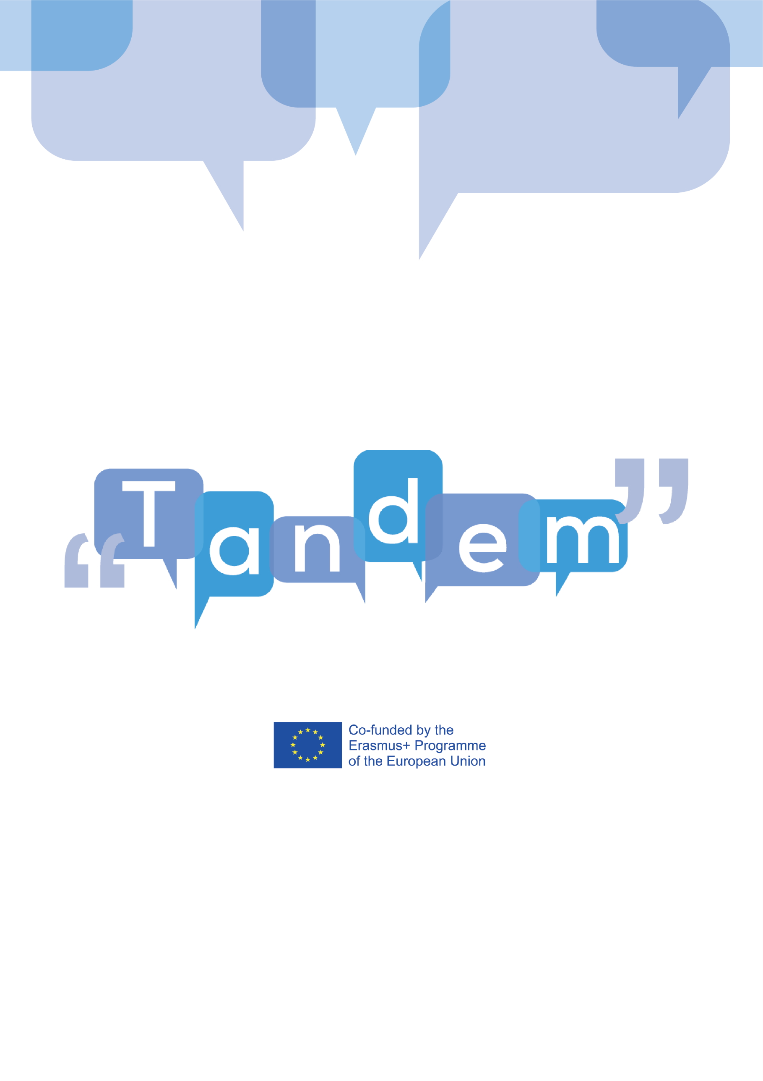

MODULE 3 - TOPIC 3.2.1: What is a task and what are the types of a task

As we said, TBLT’s main feature is the organization of a lesson or activity in Tasks. A Task can be defined as an activity based on a real-life situation or problem that can be used to work on a specific topic. It involves a communicative problem to solve and its main aim is to convey a message. This “forces” the student to figure out, use, and therefore learn, the language. A task is assessed in terms of the message conveyed. In other words, it’s successful if the message gets through even though the language used was not perfect.
- Rod Ellis defines tasks in terms of four key criteria:
  - The core characteristic of tasks is meaning because the main goal of learners is to produce, understand and convey a message.
  - Another characteristic is gaps: tasks should involve gaps, which are communicative problems to solve. In order for learners to be engaged in the activity, they need to have a reason to do it, they need to have “a gap to fill”. There are three types of gaps. Information gaps are situations that involve the transfer of information from a person to another (for example you might ask your students to give directions to someone). These types of activities require learners to speak and to work in a group/pair to get the missing information, so that they can “fill in the gap”. It is a great way to enable your learners to speak and work together.
Opinion gaps occur when learners discuss their own personal preferences, feelings and or ideas about something, starting from the same shared information (for example you might ask your students to discuss a social or political issue, and for them to look for facts to support their views).
Reasoning gaps occur when learners are required to find a solution to a problem through the use of reason (for example choosing the best from several options, finding the most suitable/cheapest or quickest solution to a problem, etc.). Therefore, learners have a shared set of information that evolves and changes (for example, you might ask your students to solve a riddle or find the best route to get from place A to B). It is not a gap between students, but a gap between past and future knowledge.
  - Tasks aim to achieve a communicative outcome, a real communicative goal, rather than a linguistic one. The assessment of the task is positive if that communicative outcome is reached, rather than if the student used the correct language. For example, if the task is to write a cover letter for a job application, the task will be successful if the person that receives the application understands what the applicant wanted to communicate.
  - Finally, tasks are based on the use of learners’ own resources, because learners have to fill the communicative gap and reach a communicative outcome by relying solely on their own existing linguistic or non-linguistic resources, including gestures. For example, they could be asked to invite their friends to a party without knowing what language structures to use at first. They would therefore have to find a way to make their friends understand what they want to say by using the language they know or other gestures. This criterion is what differentiates TBLT from traditional language teaching where students are provided in advance with the linguistic resources they need to communicate by the teacher. For example, the teacher would first explain the grammatical rule for using the past-tense, and then students would have to do some exercises to get used to the new grammatical rule. Only then can they start communicating in the language through other interactive exercises such as role play.
- Let’s see some examples. A task could be “giving directions to a tourist in the street, from the train station to the museum”: one student plays the tourist and another plays the local person on the street in a role-play. This is a task because it relates to real-life and could happen every day; it focuses on meaning and not on the right vocabulary or grammar, as the most important thing to achieve is making sure that the tourist understands the directions given. Also, there is a communicative gap, in this case an “Information gap”, because the tourist does not know something that the student knows and there is a transfer of information between the two. The assessment of the task is based on whether the tourists reach the museum: the task will be successful if the message is rightly conveyed and the goal to get to the museum reached.
- To make it clearer let’s also see what is NOT a task? In the role-play example explained earlier the teacher could also have explained to the two students what vocabulary, structures and ideas they should use by giving them a sheet with the dialogue structure to follow: “the tourist (Student A) stops a local person (student B) on the street. A asks B where the supermarket is. B gives A the directions to the supermarket by following the path indicated on a map and using the directions vocabulary (e.g. turn right, turn left, behind, in front of etc.). B asks for clarification. A replies.. B thanks A”. In this case there is still role-play but this is not a task because it’s not a real conversation that leads to a realistic outcome but it only serves the exercise. All learners need to do here is to find the suitable and correct language to convey the meaning that is already given as part of the exercise input.
- Task Varieties – the types of tasks can vary, but the main activities used can be summarized in the following list:

TASK TYPES | EXAMPLES
LISTINGS | Brainstorming  Fact-finding  Games based on listings: quizzes, memory and guessing
ORDERING & SORTING | Classifying  Ranking ordering  Sequencing in the correct order
COMPARING AND CONTRASTING | Finding similarities and differences (in texts, videos, pictures)
PROBLEM SOLVING | Logic problem prediction
PROJECTS AND CREATIVE TASKS | Newspapers  Posters  Surveys
SHARING PERSONAL EXPERIENCE | Story telling  Memories
MATCHING | Words/phrases to pictures

TANDEM Open Textbook IO2 Ellis, Rod (2003). Task-based Language Learning and Teaching. Oxford, New York: Oxford Applied Linguistics. (Secondary source: https://www.myenglishpages.com/blog/task-based-language-teaching-tblt/)
TANDEM Open Textbook IO2 Ellis, Rod (2003). Task-based Language Learning and Teaching. Oxford, New York: Oxford Applied Linguistics. (Secondary source: https://www.myenglishpages.com/blog/task-based-language-teaching-tblt/) 7 Information Gap Activities for ESL Classroom, available at: https://www.fluentu.com/blog/educator-english/information-gap-esl/ How to Use Gaps in Communicative Activities, available at https://www.barefootteflteacher.com/blog/how-to-use-gaps-in-communicative-activities
https://www.slideshare.net/RobertDickey/tblllesson-planning

